8 September 1917 - 2 September 1970
Arthur Drexler was born in Minnesota and moved to Pierce County, Washington when he was a young man. He enlisted in the U.S. Army on 15 October 1941 and was honorably discharged on 13 September 1945. Art served as a member of the 1st Cavalry Division in Australia during WWII.

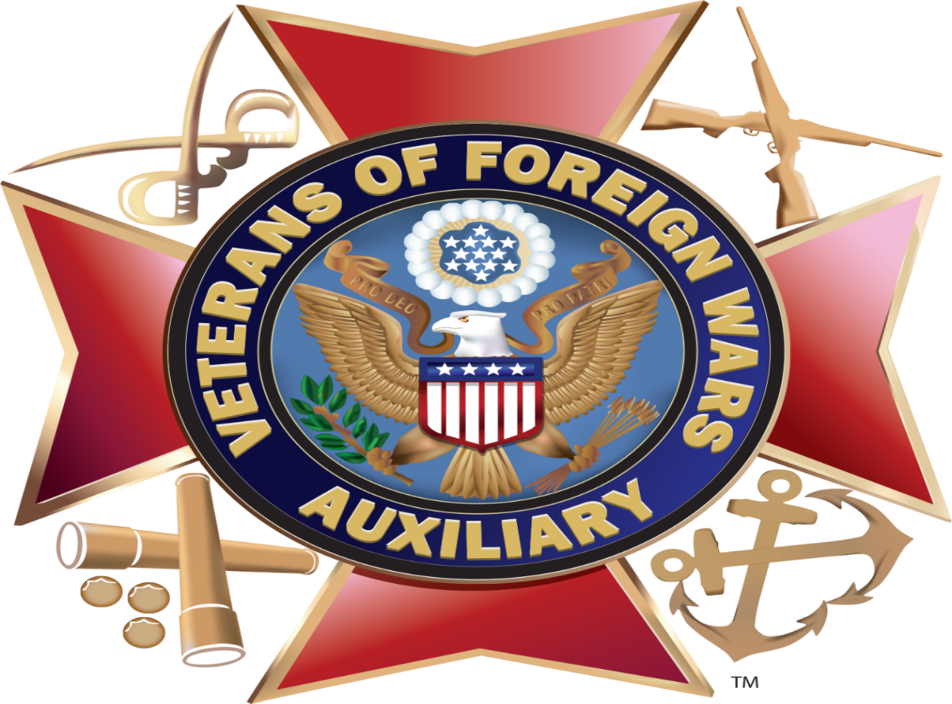

EVENTS:
- WE NEED TO HAVE A BIRTHDAY LUNCHEON FOR: MONTHS: JANUARY & FEBUARY
- OUR NEXT MONTHLY MEETING IS ON: FEBUARY 11, 2020: TUESDAY AT 7 PM
- PLACE OF MEETING:
- 325TH 152ND STREET EAST TACOMA, WA. 98445

- DISTRICT 3 MEETING: APRIL 19, 2020 AT POST #969

- THANK YOU ALL, WHO HELPED OUT WITH THE LEMAY MARYMOUNT EVENT

- NEW POST COMMANDER: TONY DAYTON (2019-2020)
- QUARTERMASTER: DOUG RIGGS (2012-2020)
- POST CHAPLAIN: JOHN APOSTOLIDES (2019-2020)

- AUXILIARY PRESIDENT: BONNIE RIGGS (2014-2020) & DISTRICT 3 JR. VICE PRESIDENT (2019-2020)
- TREASURE: GLORIA HOOTEN (2017-2020)
- SECRETARY: BETTY MOORE (2017-2020)
- CHAPLAIN: ELSIE UGLOW (2017-2020)

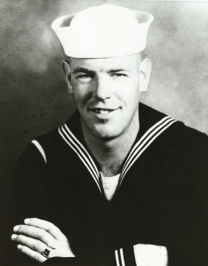
Harold LeMay in the Navy
Marymount Military Academy was a boys' military school in Tacoma, Washington that was in operation first as a military academy, then as a private boys' school from 1923 to 1976.

History
Marymount was purchased in 1919 by the Sisters of St. Dominic on the outskirts of Tacoma, Washington in present-day Parkland. The remote plot on which it stands was bought from the Shields family in 1920. The property was known as "Wright's Acre Tracts", owned by the people who built Annie Wright School. The Shields' property was located on the John Mahon Road, now known as Military Road. The inadequacy of the boys' school (St. Edward's) necessitated the building of the present Marymount Academy in 1922. At that time, Parkland was mostly prairieland. What is now Marymount was then a farmhouse, some outbuildings and rolling fields. The original two administrators of Marymount, Mother Mary Thomasina and Mother Mary de Chantal, chose the present location as a site for a school for boys, to replace Saint Edward's Hall in Tacoma.^{[1]}
The groundbreaking was in May 1921. On July 2, 1922 the cornerstone was laid and it was dedicated as St. Edward's Boys' school at Mary Mount on May 30, 1923.^{[2]} Later the name was shortened to just Marymount. Thus, began Marymount's 54 years as a military academy for boys. The school originally catered to preschoolers through ninth grade, and the students boarded in what is now the E-shaped building's west wing. A field house was added in 1952.^{[3]} The school is an outgrowth of St. Edward's hall, a pioneer Tacoma educational institution which was also opened and operated by the Dominican Sisters. The administration of the school and direction of the educational program were in the hands of the Dominican Sisters, whose Motherhouse was annexed to the academy.
Curriculum:
A 1940 Tacoma News Tribune article quoting the Dominican Sisters described the educational facilities and policies of the school as follows:
"The student body is composed of boys from six to sixteen years of age. A very high scholastic standard is maintained in all studies. The curricula include the elementary grades and junior high school studies required for accreditation by the state. The academy is also a charter member of the National Rifle Association. Manual training is provided for the boys and a well-organized industrial arts department maintained. Private instruction in music is a part of the daily schedule."^{[4]}
Early Enrollment and Curriculum:
When the school opened there were about 30 boys in attendance. The number fluctuated over the years. During World War II the number of students rose to 110. The students enjoyed a fine music program, and in addition to their choir, Marymount sponsored a band. Once a week the boys held a parade review, demonstrating the marches and drills that they had mastered that week. They also had a tradition of performing annually in the local Daffodil Parade, held in April in downtown Tacoma. A full schedule kept the boys active from reveille at 6:40am each morning until their bedtime at 9:00pm. This rigorous life proved beneficial to many students who went on to become successful in a variety of careers.

Decline:
Marymount was run as a military school until 1971; and five years thereafter as a private boys' boarding school. The academy eventually became economically infeasible. In 1974, the building underwent a vigorous renovation it became a boarding school catering to the wealthy. For example, students from the Mexican elite came to learn English. By 1976, even the boarding school had become too expensive to maintain.^{[5]}
The following decade, Marymount was for all intents and purposes a retirement home and convalescent center for the nuns. By the late 1980s, a series of catastrophic maintenance problems convinced the church to sell Marymount because it couldn’t adequately care for the facility and grounds. When the nuns solicited proposals from potential buyers, Harold LeMay’s proposal was not only the lone bid that would preserve the buildings and grounds, but he promised to maintain and improve them. The decisive element of the proposal was that the nuns were promised access to Marymount as long as they wished.
Today, several non-profit groups share space at Marymount, including a senior center, in addition to the LeMay Family Collection Foundation. It is also one of the locations for the annual LeMay Car Show and auction held on the last Saturday of August.
At one time, the Dominican sisters of Marymount operated four schools in the Tacoma area: Marymount and Aquinas Academy, a girls' school, St. Patrick's school and Holy Cross School. On September 21, 1942, they also purchased Haddaway Hall (the former J.P. Weyerhaeuser home) and opened Tacoma Catholic College, a junior college for girls. In 1974, Aquinas Academy, one of three Catholic high schools in the Tacoma area at the time, and St. Leo's, combined with Bellarmine Academy which was operated by the Jesuits.^{[6]}

Marymount Military Academy
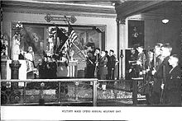
Boys at Mass before Military Day. Taken at historic Marymount Academy in Tacoma, WA.
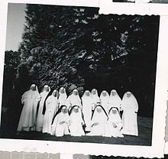
A historic picture of Dominican nuns taken at Marymount in Tacoma, WA.
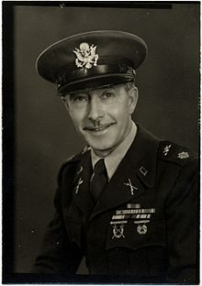
John Gress, Marymount Military Academy Commandant, 1950's. From personal collection, Scott Gress.

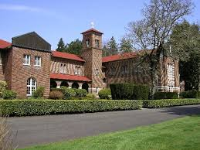

Marymount Military Academy
From 1919 to 1975, Marymount was a military academy in Tacoma, WA, run by the Sisters of Saint Dominic. For more information, visit http://www.lemaymarymount.org/lemay-collections/ or email info@lemaymarymount.org

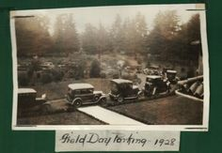
Field Day Parking-1928

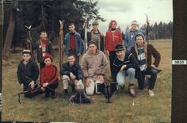
1956-Marymount students preparing for a ski trip
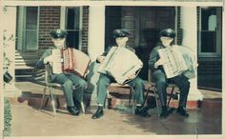

1968 - Accordion players at Marymount.

1956 - Students playing chess at Marymount
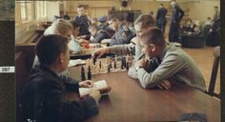

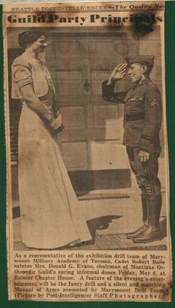
A photo of a Marymount Drill team member in a 1938…

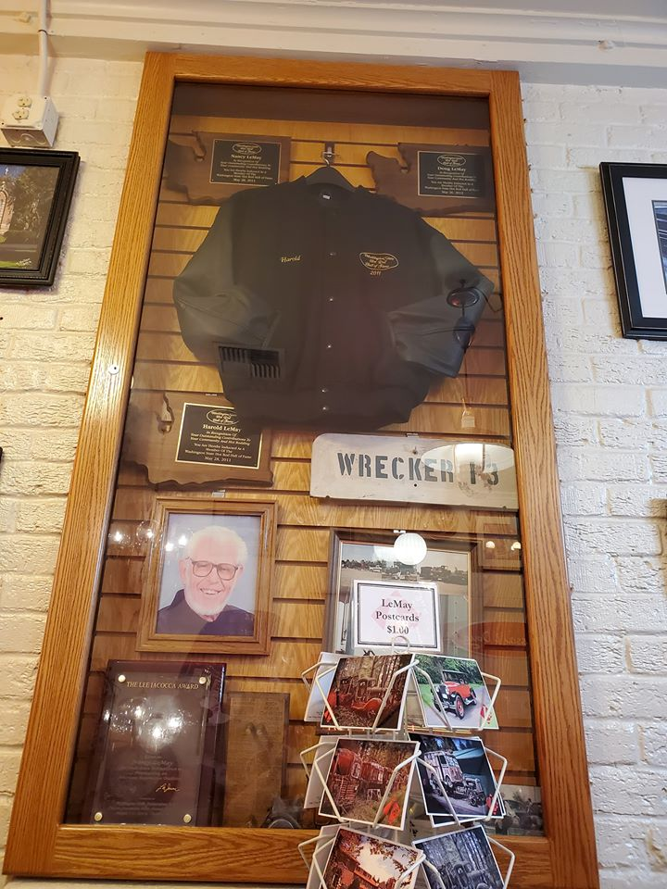

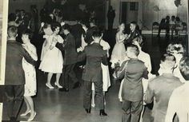
Marymount 1964 Dance

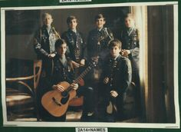
Marymount, 1972-1973

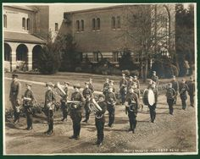
"Marymount Military Band - 1934"

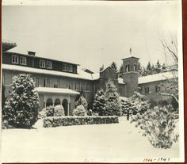

Marymount Winters, 1946-1947

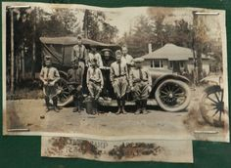

Summer Camp 1925
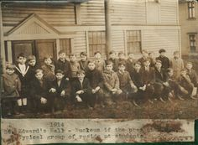

THE STORY OF HAROLD LEMAY COLLECTIONS
After Harold LeMay died in 2000, his family donated $15 million and about 600 cars to the nonprofit Harold E. LeMay Museum, with the idea that it would become a Pierce County showplace to honor the man and his offbeat passion for automotive Americana.
But over the 15 years it took to finance and build the Tacoma museum, the organization veered away from LeMay’s original vision to attract broader, national attention and investors. A name change exemplified the marketing strategy: the Harold E. LeMay Museum became the LeMay-America’s Car Museum, or ACM for short.
The Tacoma museum also ended up with less space than hoped. Plans for a 203,000-square-foot museum and a 10-story glass-encased Tower of Horsepower for 800 cars became a single, 165,000-square-foot building.
Most of the LeMay collection stayed right where it was, at a former boys’ military academy in Spanaway called Marymount.
In a move that infuriated some LeMay loyalists (LeMay family members sometimes call them FOHs for “Friends of Harold”), the new museum sold many of the LeMay cars that had been donated to it.
At two Bonhams & Butterfields auctions at Tacoma’s Murano Hotel in 2009 and 2010, the museum sold 145 LeMay cars, including a 1936 Rolls Royce touring car for $65,520 and a 1929 Buick Series 121 convertible for $42,120. Museum officials have continued selling other cars from the collection since, at auction and on eBay.
David Madeira, ACM’s chief executive officer, says the cars sold either were redundant or otherwise unsuitable for the museum collection. He also notes that Nancy and Doug LeMay (Harold’s widow and son), who sit on ACM’s board, did not vote against the sales.
Dismayed that the collection was being broken up – exactly what Harold LeMay had wanted to avoid – the LeMay’s, plus friends and supporters, bought back more than 150 of the cars and trucked them home to the collection at Marymount.
On Aug. 13, 2010, the LeMay family formed its own nonprofit corporation, the LeMay Family Collection Foundation, and opened for public tours six days a week.
The foundation has about 1,800 vehicles at Marymount and in storage nearby, including about 250 at the LeMay family home, a place Harold LeMay used to refer to as “a three-story house with a 300-car garage

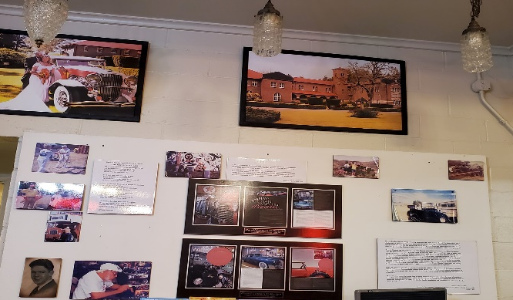

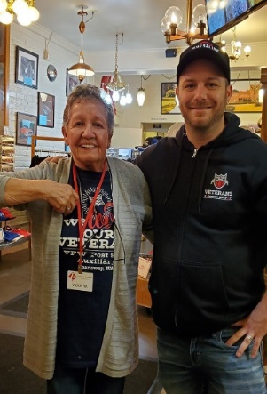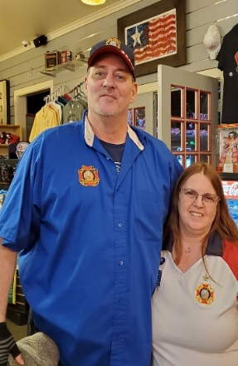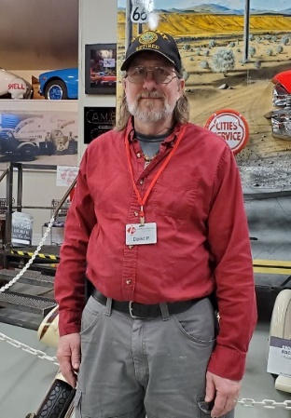
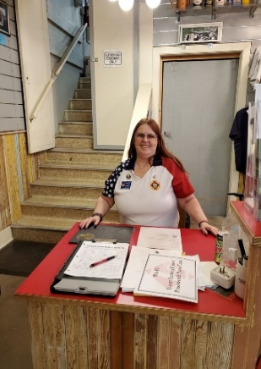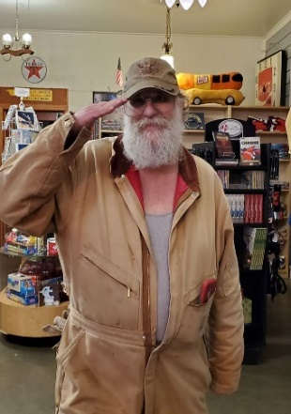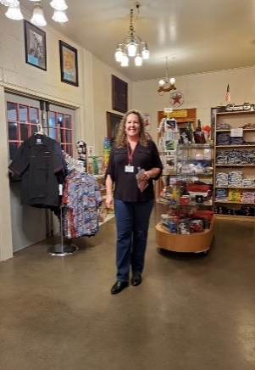
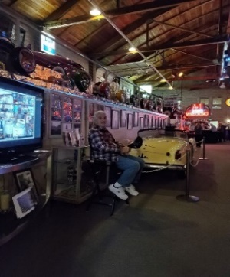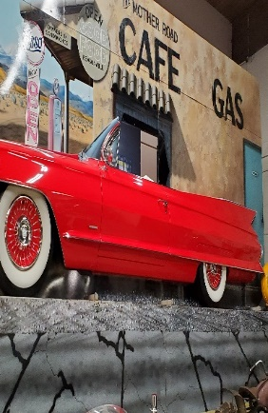

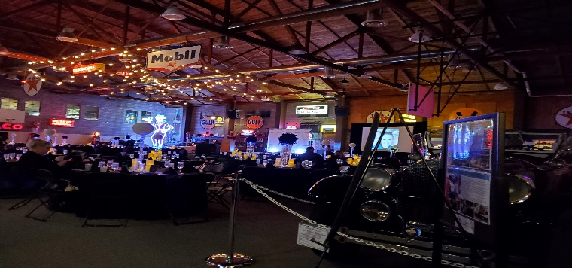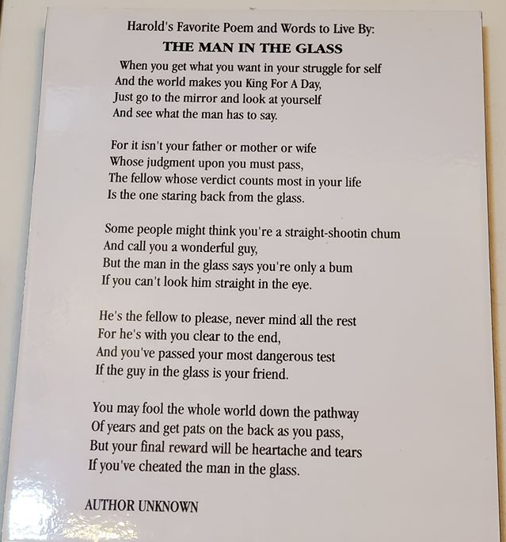

LEMAY MARYMOUNT COLLECTION 2020
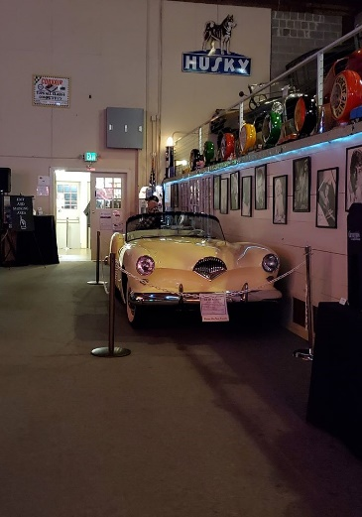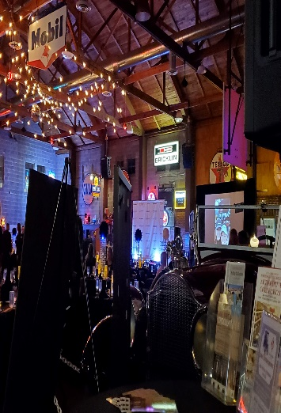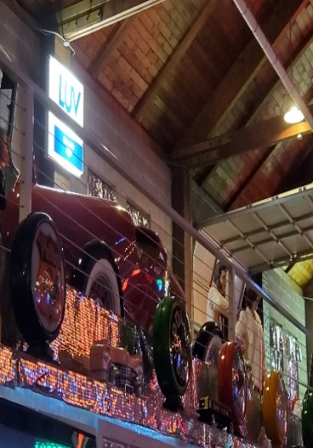
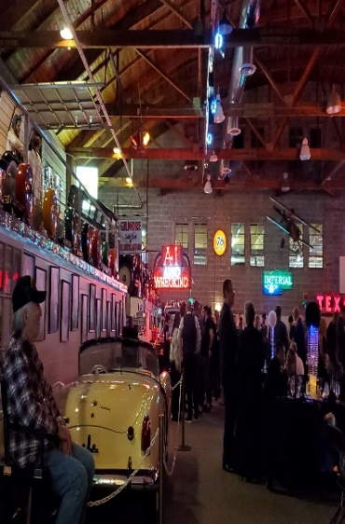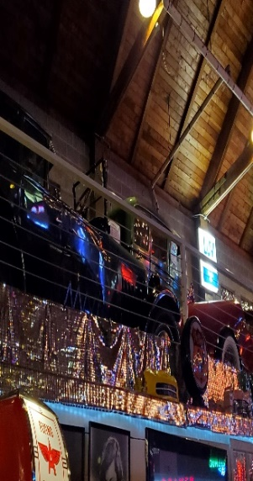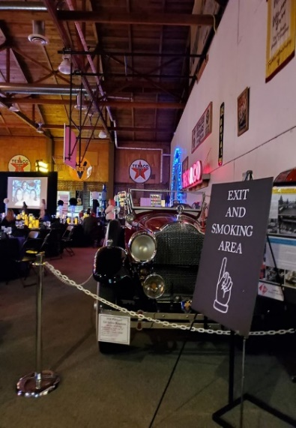

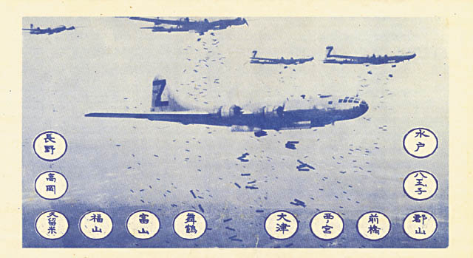
Caption from CIA article: Front side of OWI notice #2106, dubbed the “LeMay bombing leaflet,” which was delivered to Hiroshima, Nagasaki, and 33 other Japanese cities on 1 August 1945. The Japanese text on the reverse side of the leaflet carried the following warning: “Read this carefully as it may save your life or the life of a relative or friend. In the next few days, some or all of the cities named on the reverse side will be destroyed by American bombs. These cities contain military installations and workshops or factories which produce military goods. We are determined to destroy all of the tools of the military clique which they are using to prolong this useless war. But, unfortunately, bombs have no eyes. So, in accordance with America's humanitarian policies, the American Air Force, which does not wish to injure innocent people, now gives you warning to evacuate the cities named and save your lives. America is not fighting the Japanese people but is fighting the military clique which has enslaved the Japanese people. The peace which America will bring will free the people from the oppression of the military clique and mean the emergence of a new and better Japan. You can restore peace by demanding new and good leaders who will end the war. We cannot promise that only these cities will be among those attacked but some or all of them will be, so heed this warning and evacuate these cities immediately.” (See Richard S. R. Hubert, “The OWI Saipan Operation,” Official Report to US Information Service, Washington, DC 1946.)
Made by a family member of Harold E. LeMay (General Curtis LeMay)
I thought this was a very interesting article.

MID WINTER CONVENTION IN YAKAMA
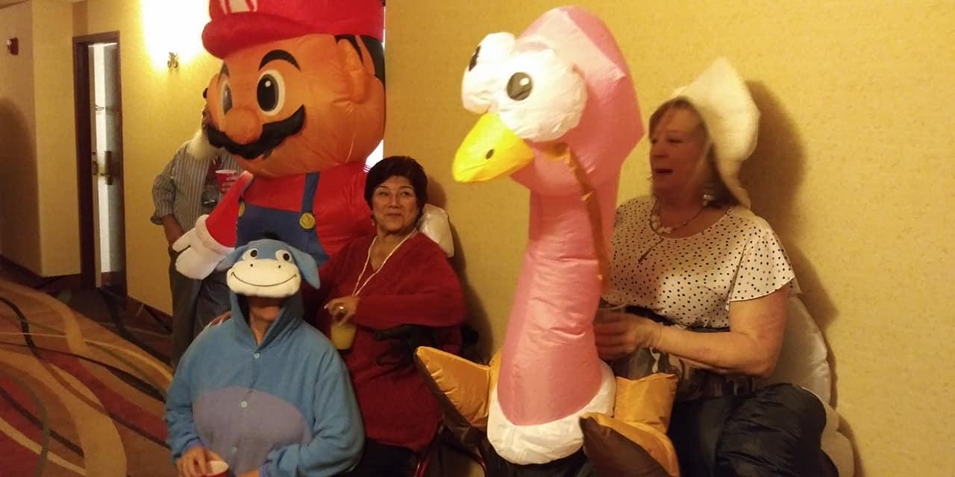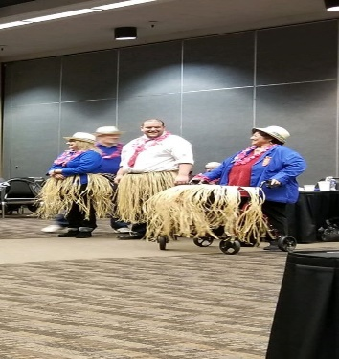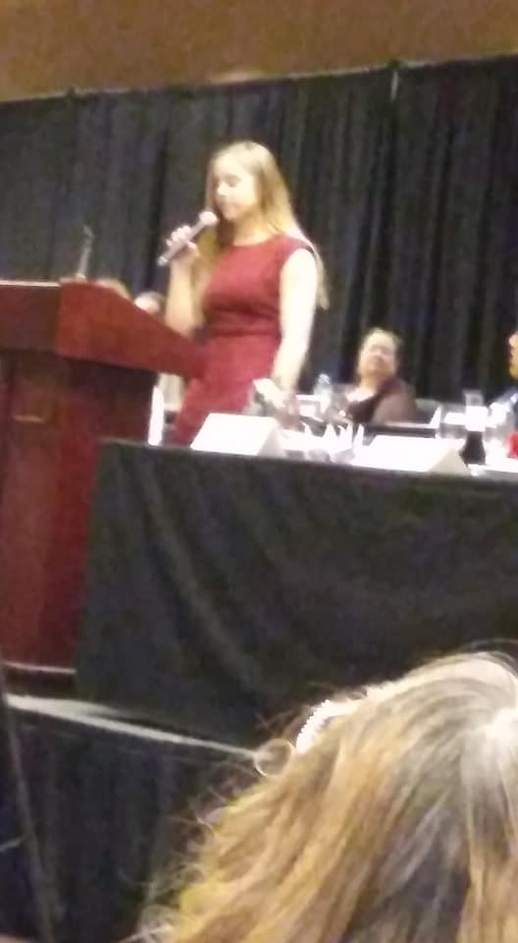
WINNER
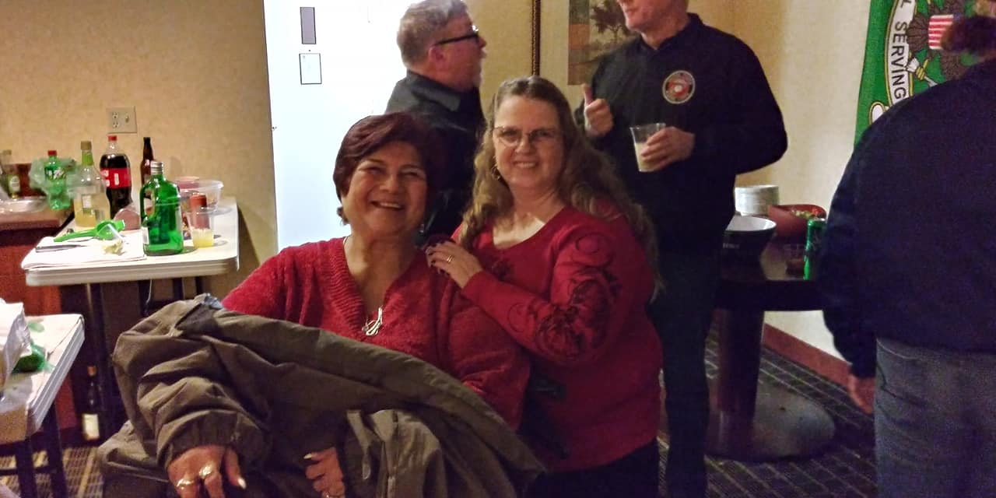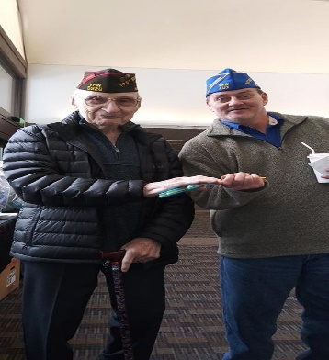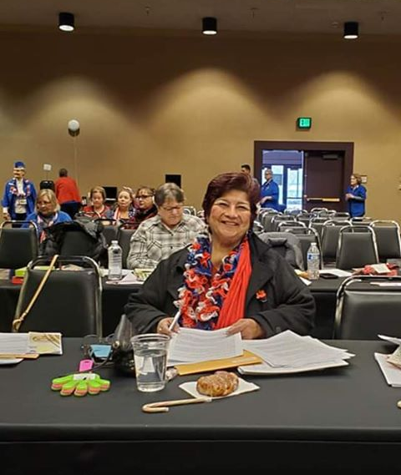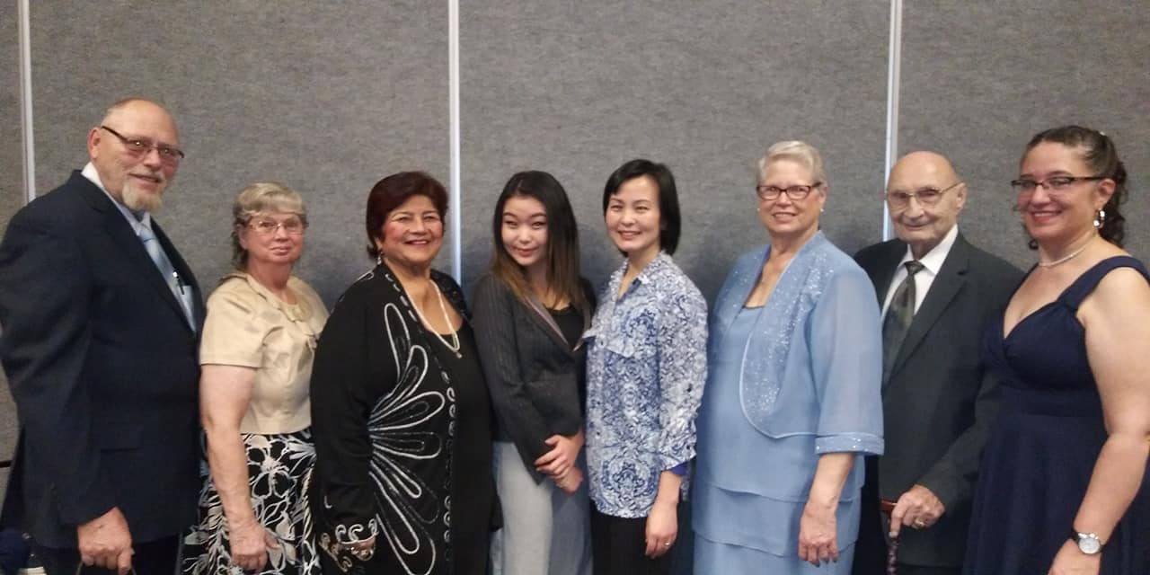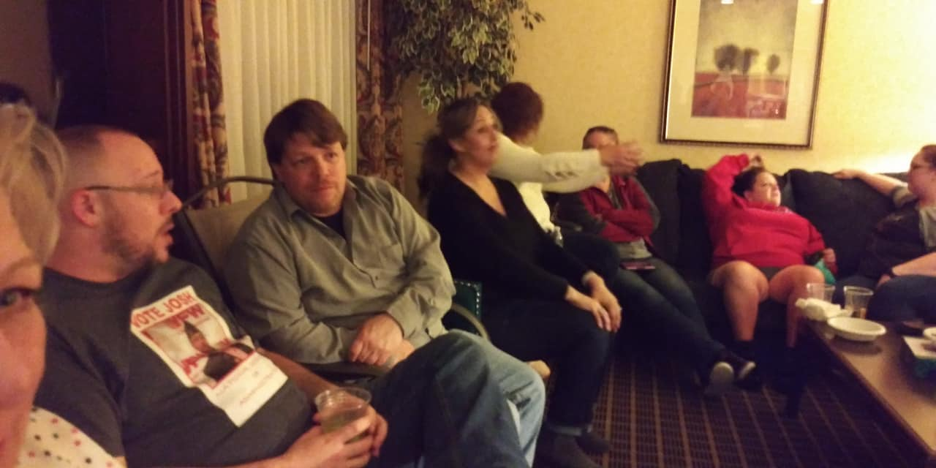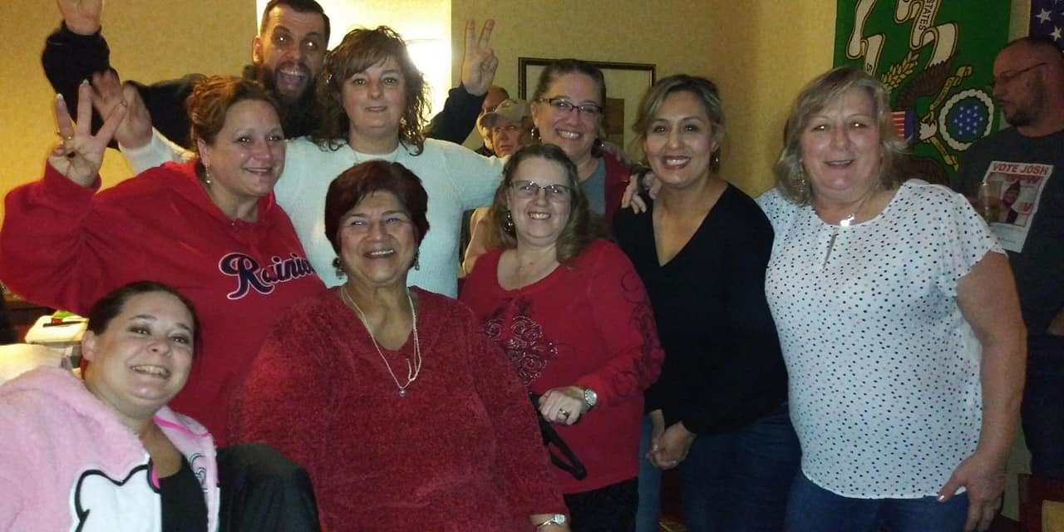
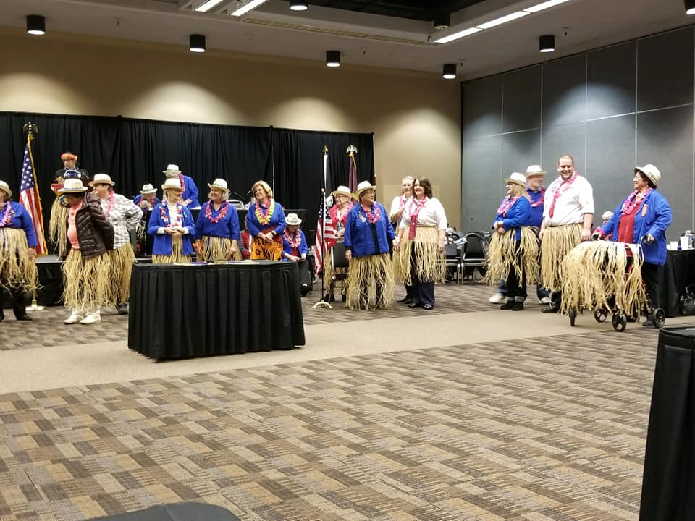

FEBRUARY IS BLACK HISTORY MONTH
- FEBRUARY 4TH WORLD CANCER DAY
- FEBRUARY 7TH, NATIONAL WEAR RED DAY
- FEBRUARY 7TH NATIONAL GIVE A KID A SMILE DAY
- FEBRUARY 14TH, VALENTINES DAY
- FEBRUARY 15TH, INTERNATIONAL CHILDHOOD CANCER
- FEBRUARY 15TH, SUSAN B. ANTHONY DAY
- ^{FEBRUARY 17TH, PRESIDENTS DAY}
- FEBRUARY 19TH, COAST GUARD RESERVES BIRTHDAY (1941)
- FEBRUARY 25TH, FAT TUESDAY (MARDI GRAS)
- FEBRUARY 29TH, RARE DISEASE DAY
- AMERICAN HEART DISEASE AWARNESS MONTH
- NATIONAL CANCER PREVENTION AWARNESS MONTH
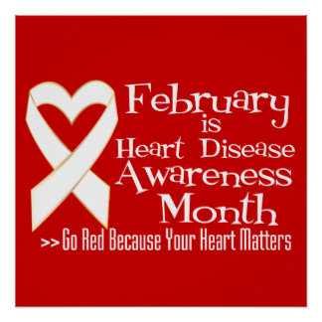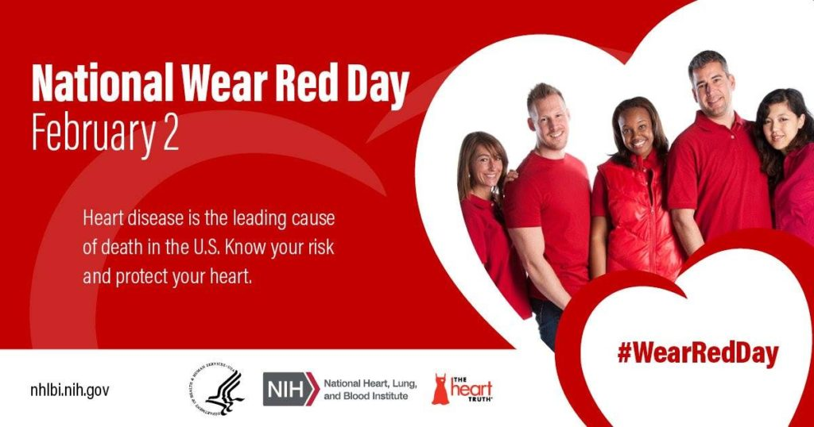
This Photo by Unknown Author is licensed under CC BY-SA
This Photo by Unknown Author is licensed under CC BY-SA-NC

This Photo by Unknown Author is licensed under CC BY
This Photo by Unknown Author is licensed under CC BY-ND

CALENDAR 2020
JANUARY
VFW/AUX POST 9079 EVENTS TO COME

SUNDAY | MONDAY | TUESDAY | WEDNESDAY | THURSDAY | FRIDAY | SATURDAY
 |  |  | 1 | 2 | 3 | 4
5 | 6 | 7 | 8 | 9 | 10 | 11
 |  |  |  |  |  | VOD SCHOLARSHIP PROGRAM
12 | 13 | 14 | 15 | 16 | 17 | 18
DISTRICT 3 MEETING POST 91 | NEW VFW/AUX MEETING PLACE 6:30 PM |  |  | MID WINTER CONVENTION IN YAKIMA | MID WINTER CONVENTION IN YAKIMA | MID WINTER CONVENTION IN YAKIMA
19 | 20 | 21 | 22 | 23 | 24 | 25
CONVENTION YAKIMA HAVE A SAFE TRIP HOME EVERYONE
26 | 27 | 28 | 29 | 30 | 31

Iraq War Veterans – Paving the Way for How we Treat those Returning Home
CALENDAR 2020
FEBRUARY
VFW/AUX POST 9079 COMING EVENTS
HAPPY VALENTINES DAY
SUNDAY | MONDAY | TUESDAY | WEDNESDAY | THURSDAY | FRIDAY | SATURDAY
 |  |  |  |  |  | 1
2 | 3 | 4 | 5 | 6 | 7 | 8
LAMAY MARYMOUNT EVENT VOLUNTEER HOURS
5 PM-11PM
9 | 10 | 11 | 12 | 13 | 14 | 15
 |  | VFW/AUX NEW MEETING PLACE AT LAMAY MARYMOUNT
16 | 17 | 18 | 19 | 20 | 21 | 22
23 | 24 | 25 | 26 | 27 | 28 | 29
 |  |  |  |  |  | LEAP YEAR
CALENDAR 2020
POST 9079 EVENTS TO COME

MARCH
SUNDAY | MONDAY | TUESDAY | WEDNESDAY | THURSDAY | FRIDAY | SATURDAY
1 | 2 | 3 | 4 | 5 | 6 | 7
8 | 9 | 10 | 11 | 12 | 13 | 14
 |  | VFW/AUX MONTHLY MEETING MARYMOUNT 7PM
15 | 16 | 17 | 18 | 19 | 20 | 21
 |  | SAINT PATRICK’S DAY
22 | 23 | 24 | 25 | 26 | 27 | 28
29 | 30 | 31
SPAGHETTI FEED POST 91 4PM-6PM

